**LAPORAN TUGAS AKHIR BAHASA PEMROGAMAN**

**APLIKASI SISTEM INFORMASI PERPUSTAKAAN**



**Dibuat Oleh :**

**Alfisal Punjung Kurniawan (200101003)**

**UNIVERSITAS DUTA BANGSA**

**2020 / 2021**

**KATA PENGANTAR**

Segala puji bagi Allah yang telah memberikan rahmat serta hidayahnya sehingga kami dapat menyelesaikan project UAS untuk mata kuliah Bahasa Pemrogrman dengan judul: “**Aplikasi Sistem Informasi Perpustakaan**”.

Saya menyadari sepenuhnya bahwa laporan ini jauh dari sempurna dikarenakan terbatasnya pengalaman dan pengetahuan yang saya miliki, Oleh karena itu kami mengharapkan segala bentuk saran dan masukan bahkan kritik yang membangun dari berbagi pihak. Akhirnya kami berharap semoga makalah ini dapat memberikan manfaat bagi perkembangan

Surakarta, 13 July 2021

Penulis

**DAFTAR ISI**

**COVER HALAMAN i**

**KATA PENGANTAR ii**

**DAFTAR ISI iii**

**BAB l MEMBUAT DATABASE 1**

1. Mengaktifkan Xampp 1
2. Proses Pembuatan Data Base 1

**BAB ll MEMBUAT FORM DAN MENAMBAH FORM 11**

1. Proses Pembuatan Form 11

**BAB lll PROSES MEMBUAT FORM DAN MENAMBAH LISTING 14**

1. Form Utama / Aplikasi Perpustaka 14
2. Form Login 16
3. Form Staff 20
4. Form Data Buku Perpustakaan 25
5. Form Peminjaman 32
6. Link Google Drive 46

**BAB I**

**MEMBUAT DATABASE**

1. Mengaktifkan Xampp
2. Mengaktifkan Xampp Control
3. Membuat data base “db_perpustakaan” , buka di browser lalu ketik “localhost/phpmyadmin”
4. Membuat data base dan 4 Tabel: tbbuku, tbpeminjam, tbstaff, tb_admin
5. Proses Pembuatan Data Base

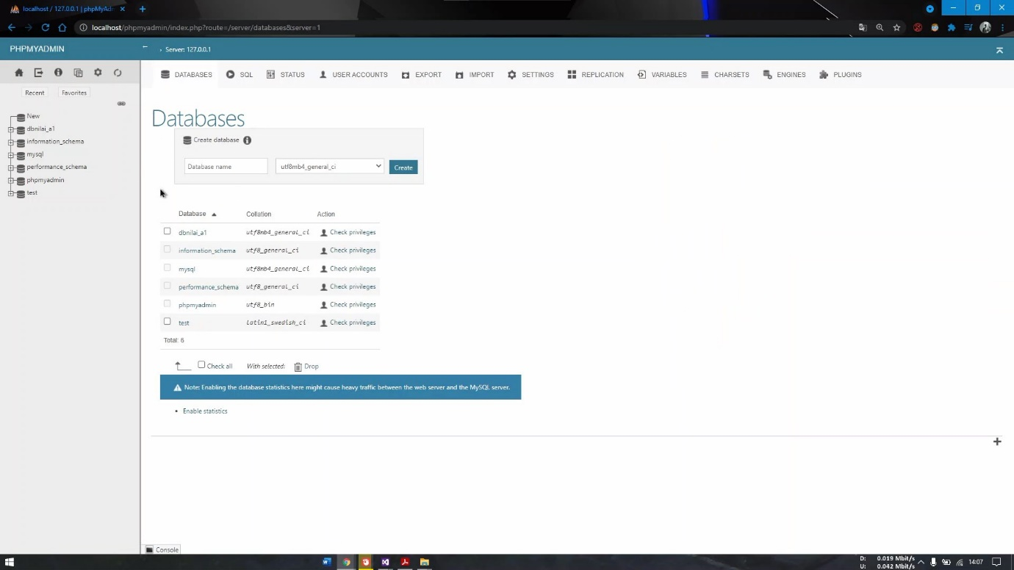

1. Membuat table : tbstaff dengan jumlah 3 kolom

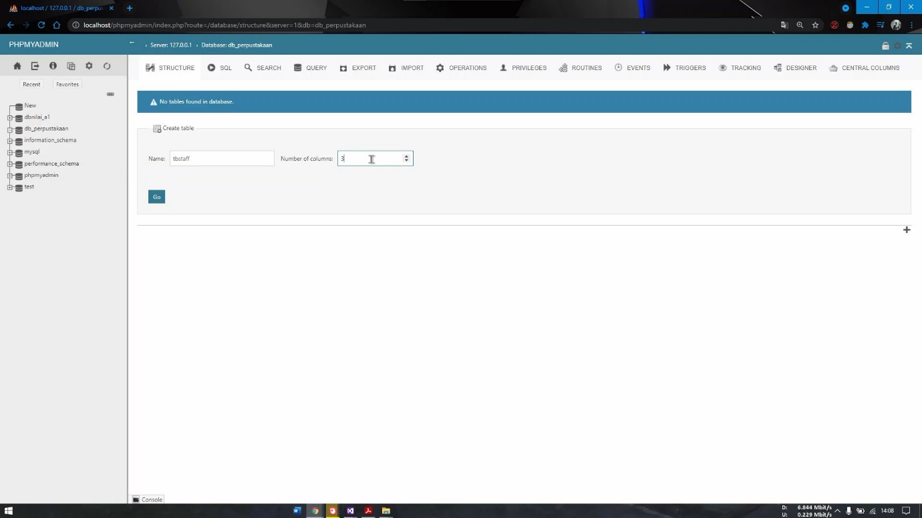

1. Isikan Kolom pada table “tbstaff” lalu klik save

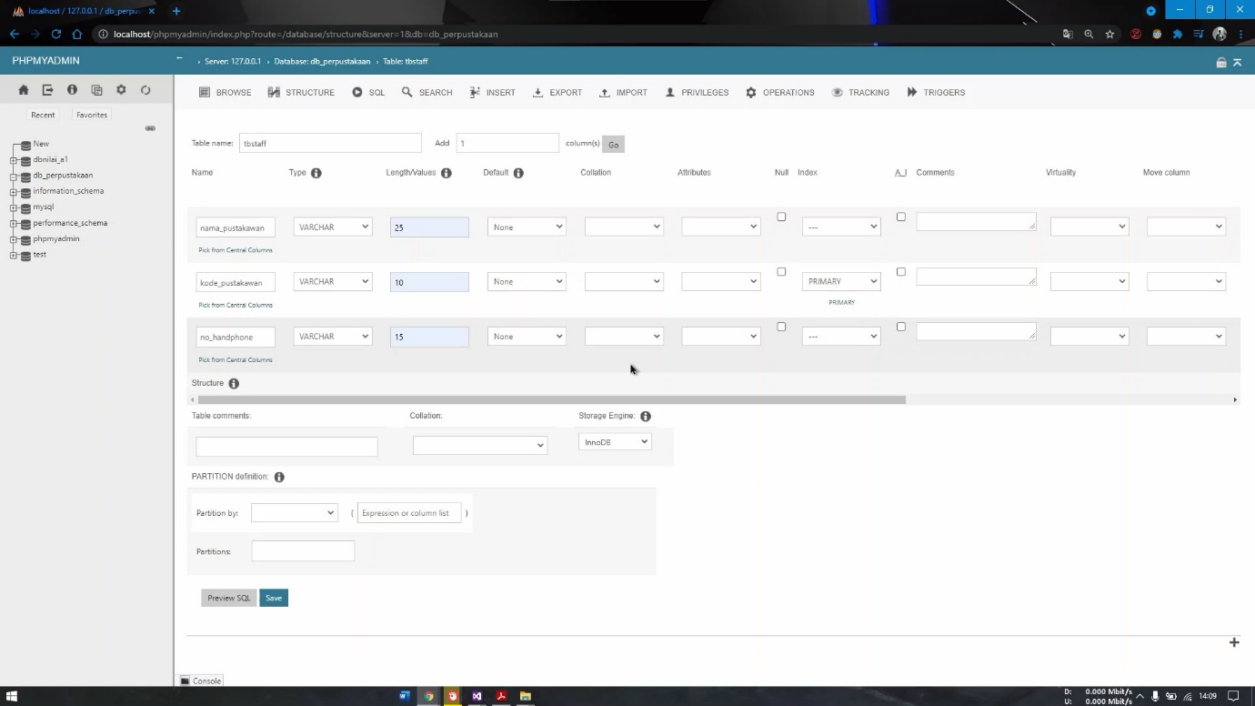

1. Membuat table “tbbuku ” dan isikan kolom seperti gambar dibawah

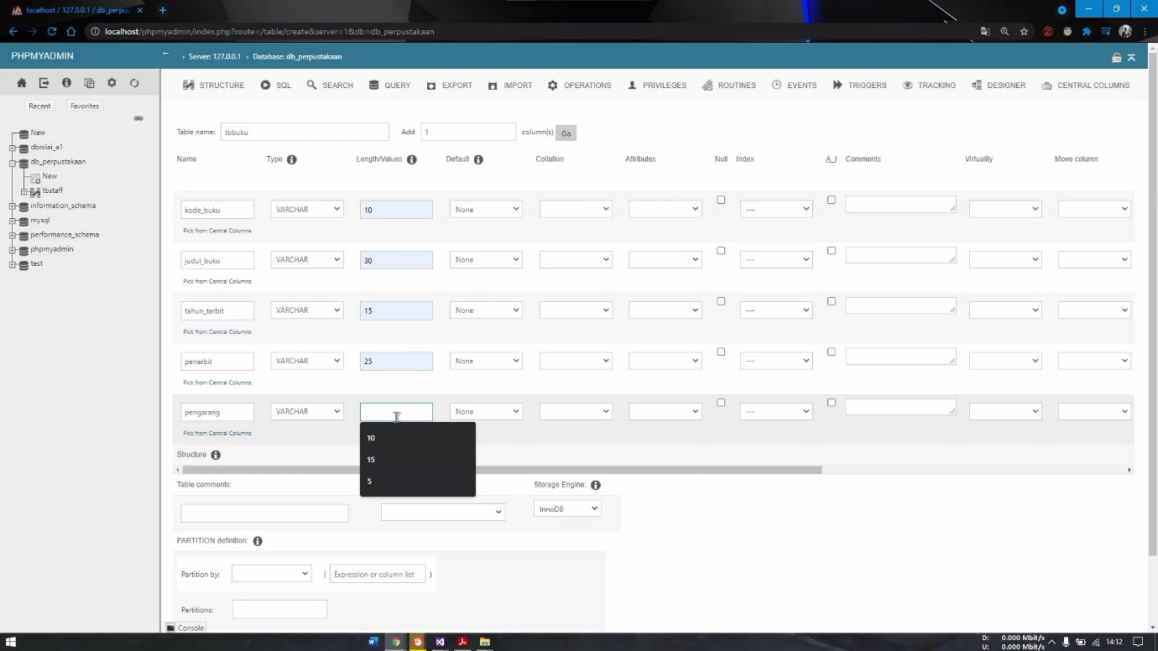

1. Membuat tb peminjam isi dari setiap field / kolom

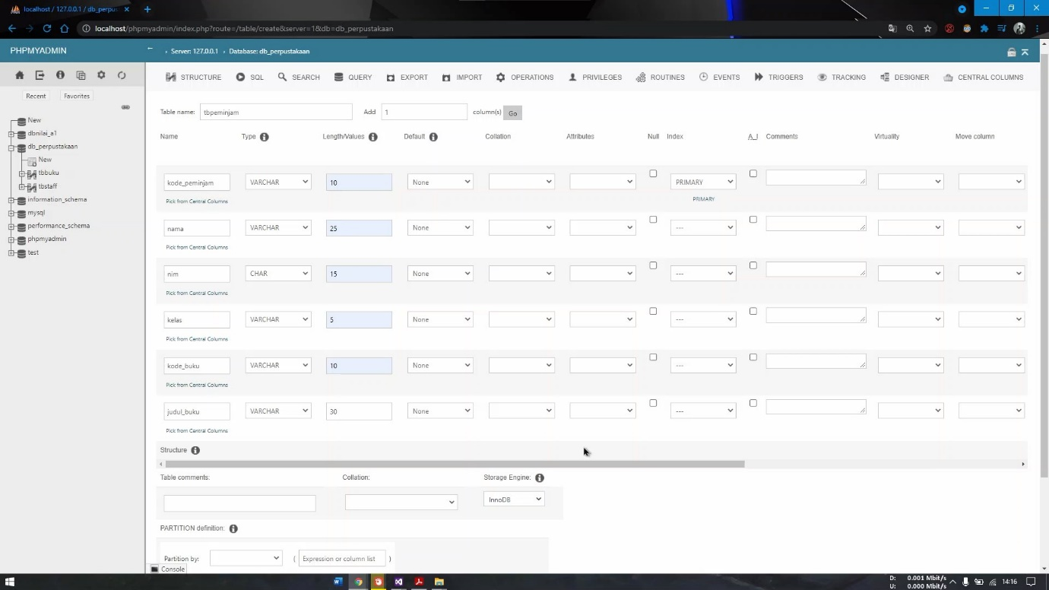

1. Lanjutan, Membuat 10 kolom

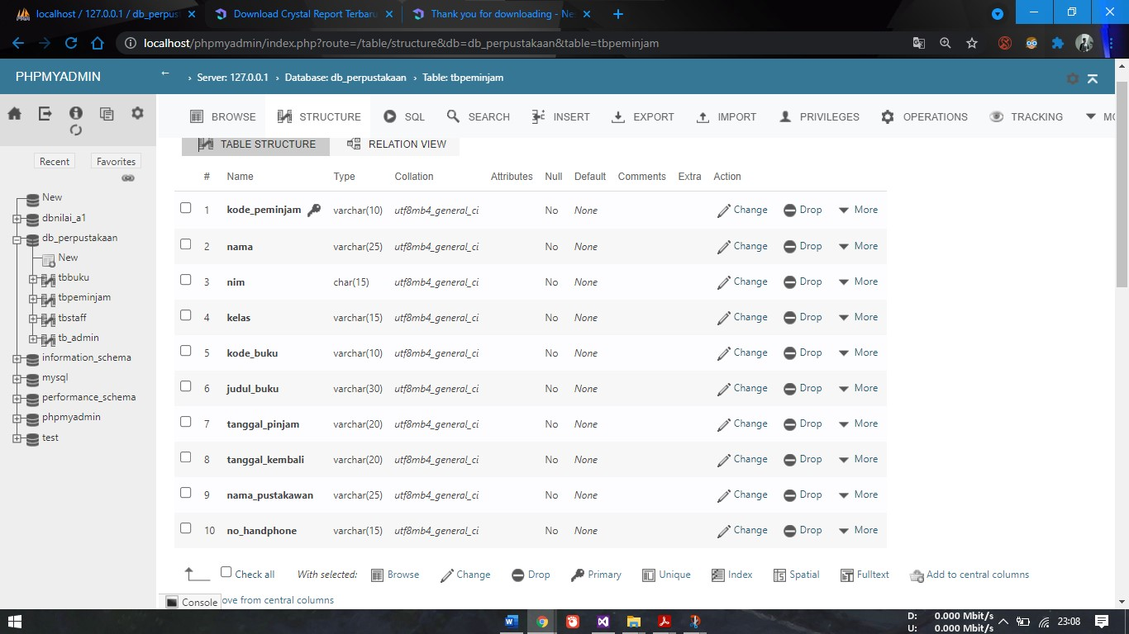

1. Buat table : “tb_admin” untuk pembuatan form login

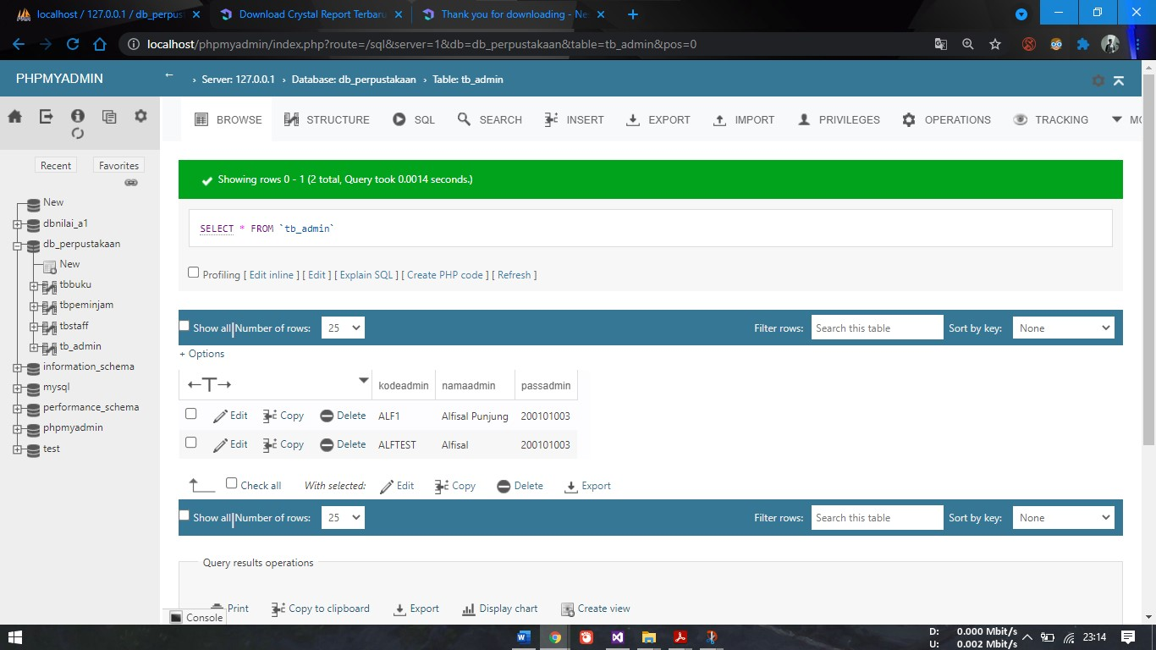

1. Setting pada MySQL Connector atau ODBC connector yang sudah diinstal, search “ODBC” atau bisa melewati Control Panel ->Administrative tools - > pilih ODBC Data Source

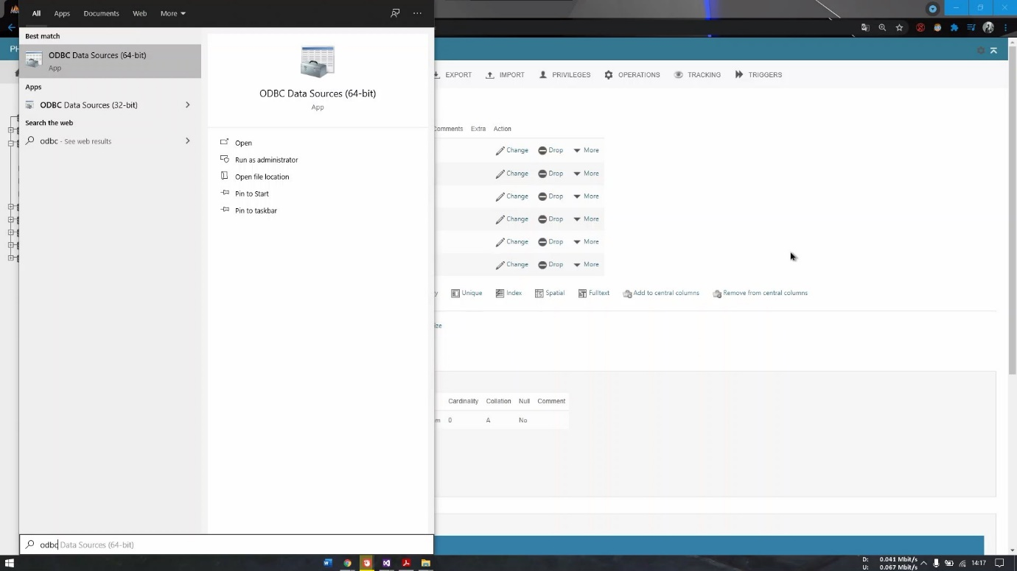

1. Klik Add untuk menambahkan

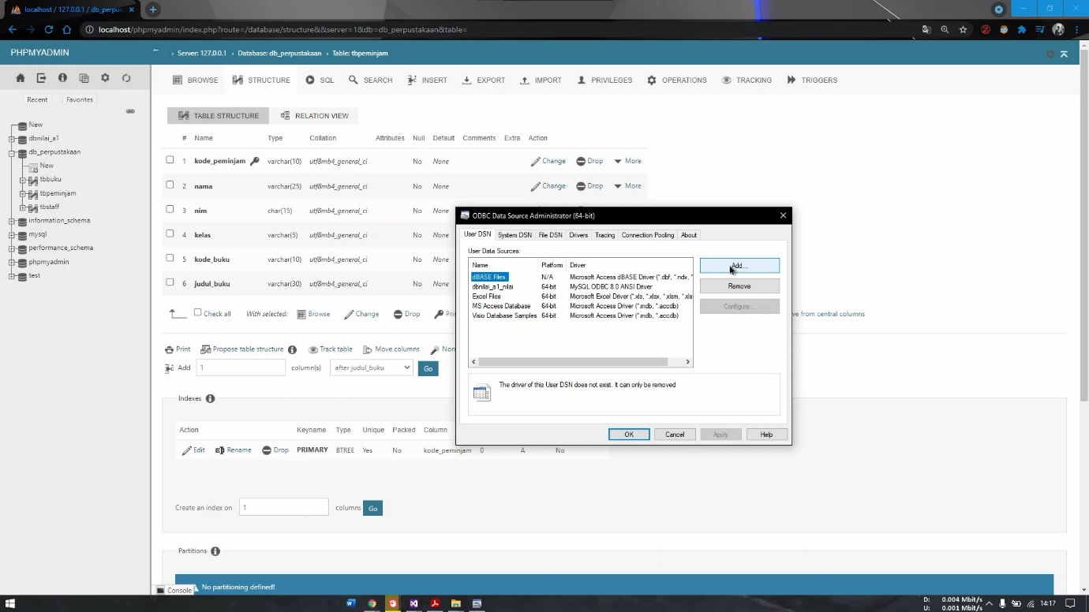

1. 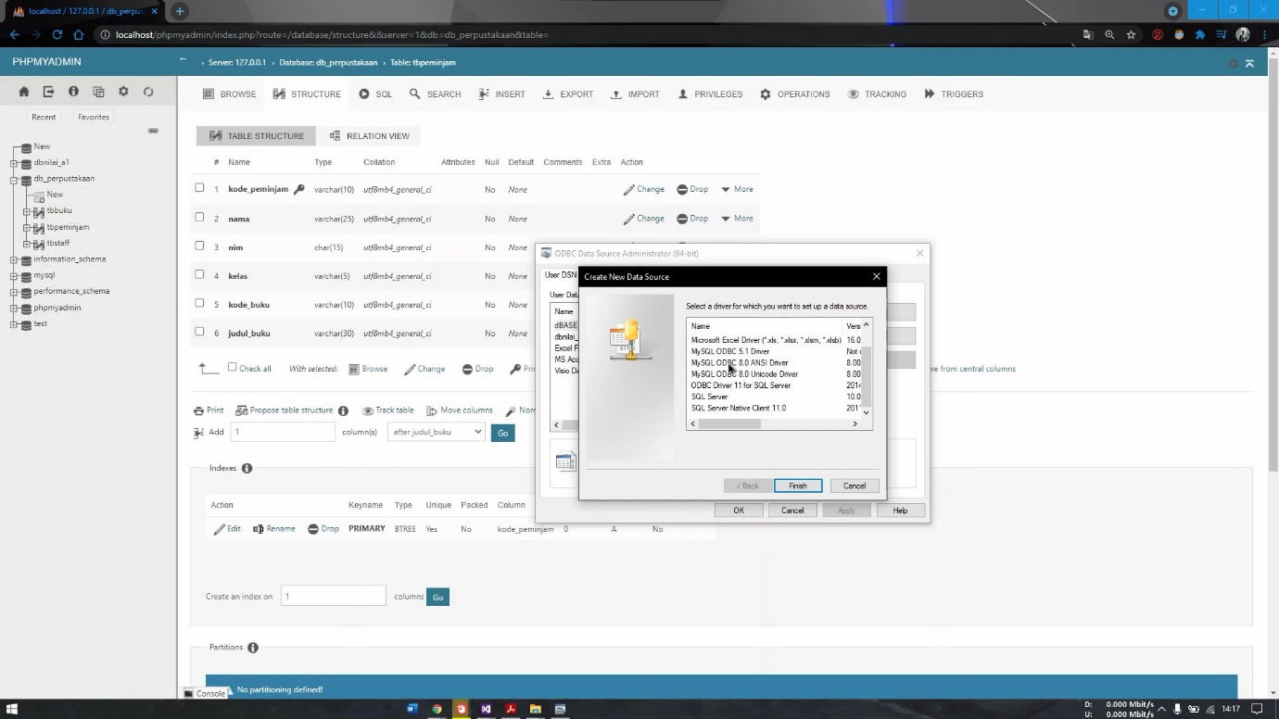Pilih driver MySql 8.0 ANSI Driver yang sudah terinstall (dengan versi 8.0)
2. Isikan data source yang akan digunakan untuk menghubungkan database ke Visual Basic, isikan user : “root”, pilih data base yang sudah dibuat tadi, lalu klik test

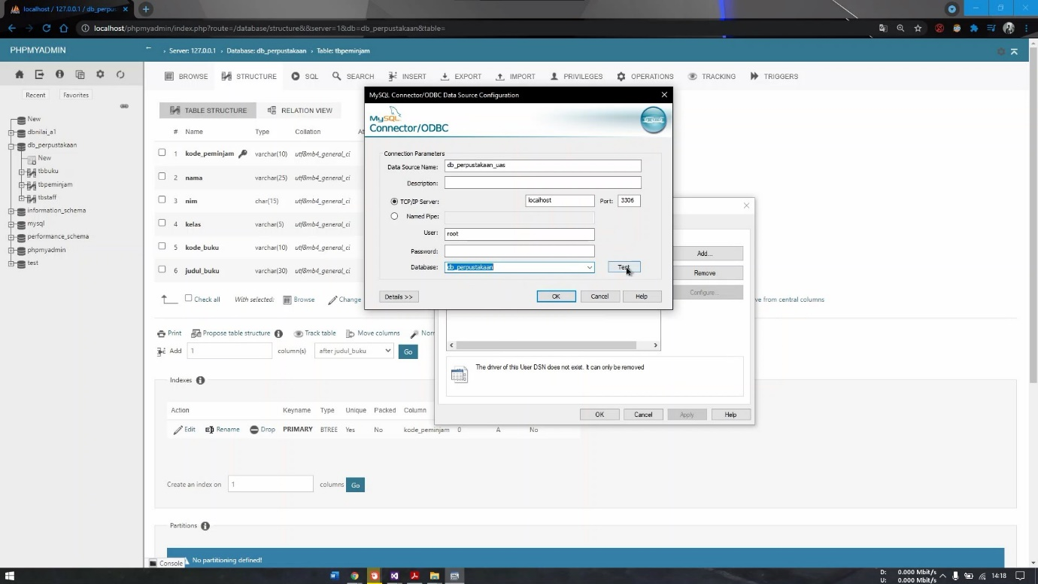

1. Hasil Terkoneksi odbc ke database yang sudah dibuat akan muncul notifikasi “Connection Succesful”

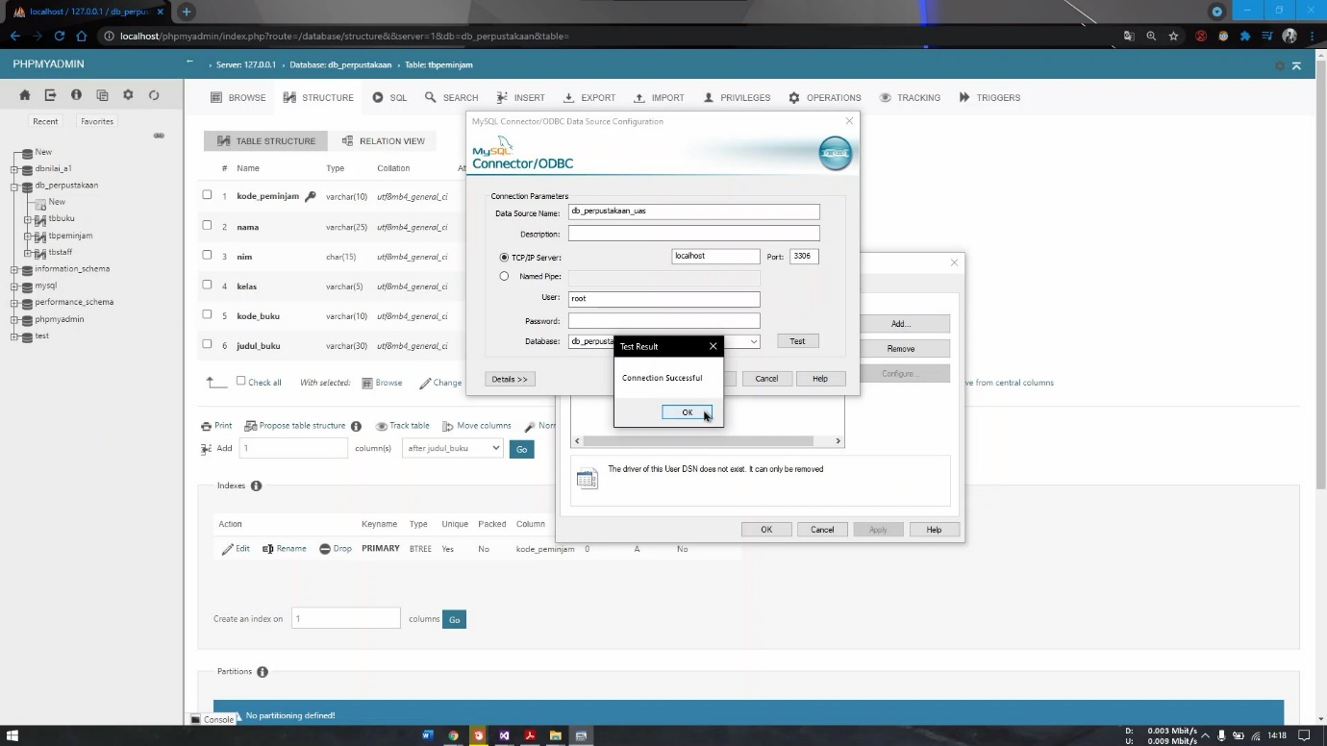

**BAB II**

**MEMBUAT FORM DAN MENAMBAH FORM**

1. Proses Pembuatan
2. Buka Aplikasi Visual Basic 2012 Ultimate
3. Buat Form, Klik New Project,

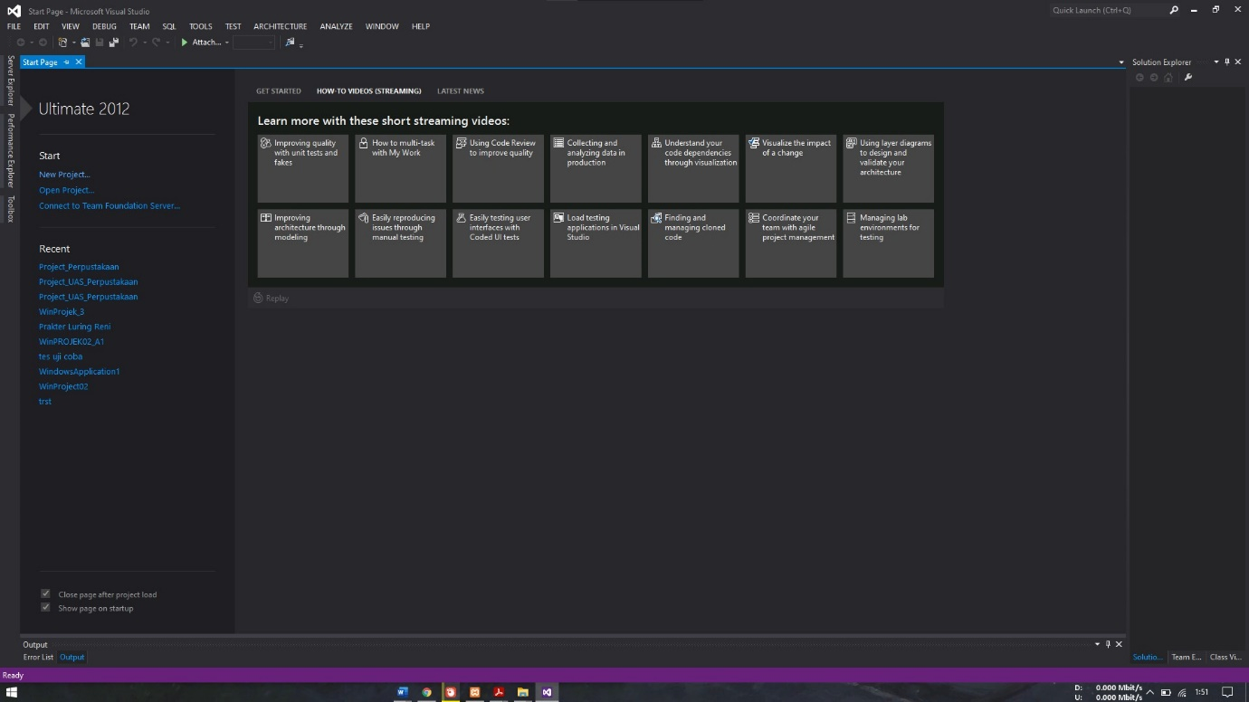

1. Isikan Nama “Project_UAS_Perpustakaan”

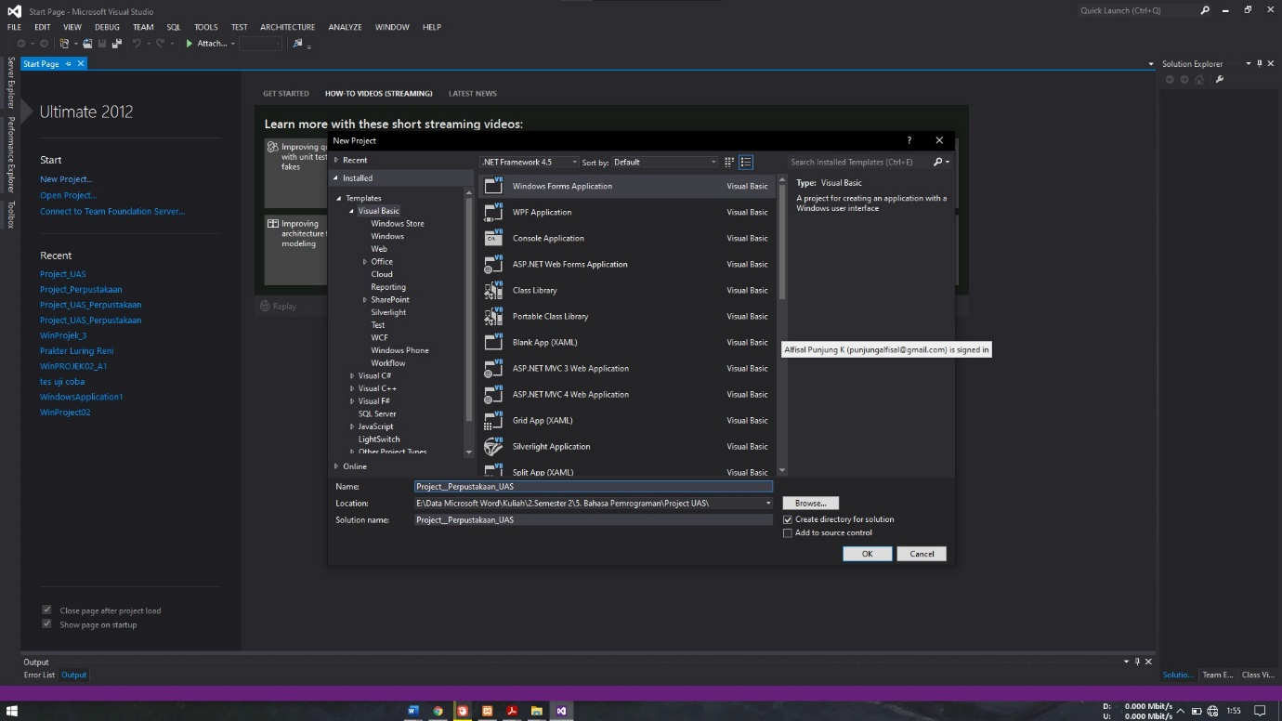

1. Klik Ok dan langsung di form pertama

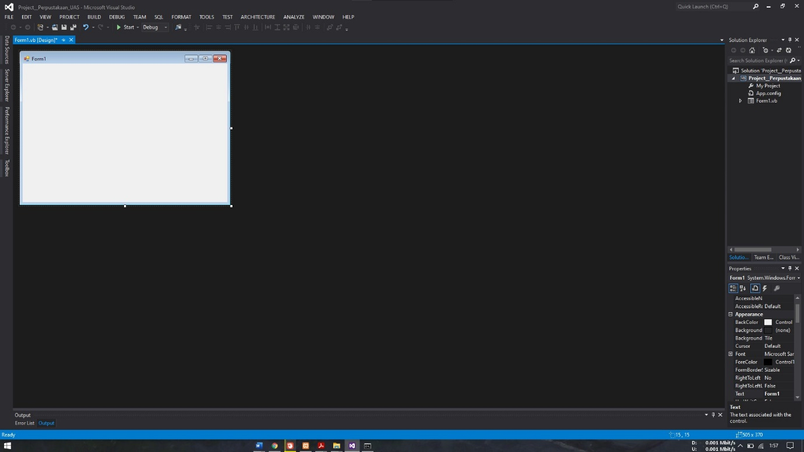

1. Menambah Form Klik Menu Project Pilih “Add Windows Form”

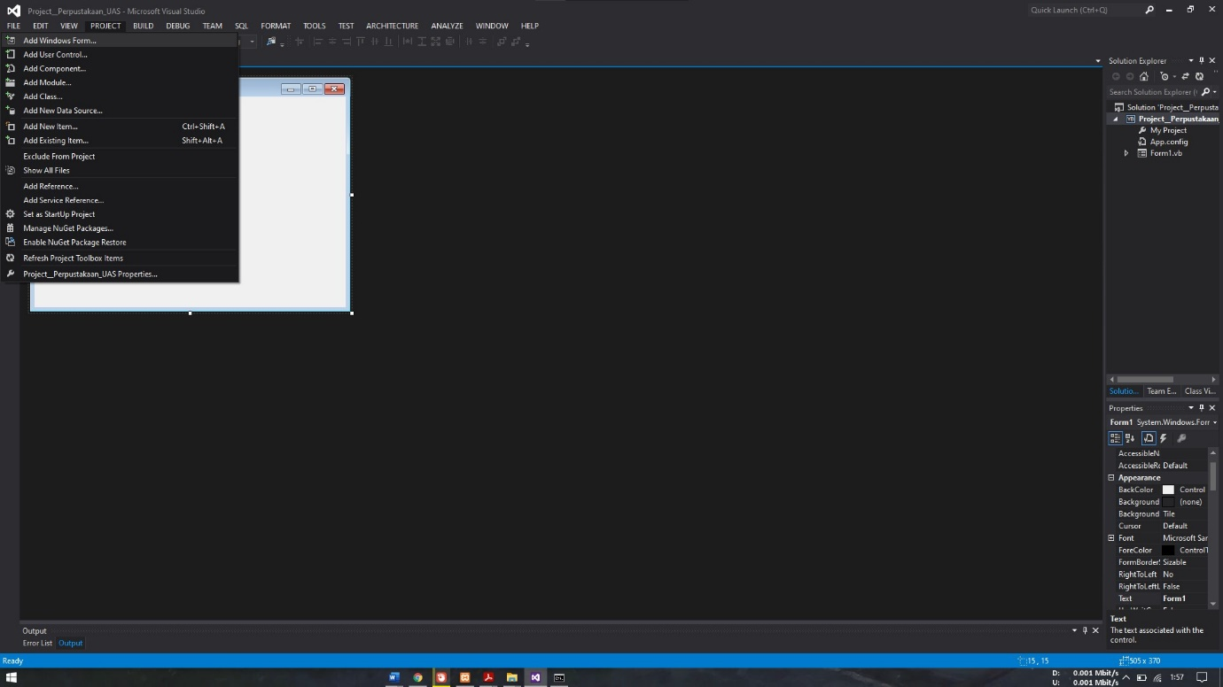

1. Baeri Nama Aplikasi_Perpustakaan

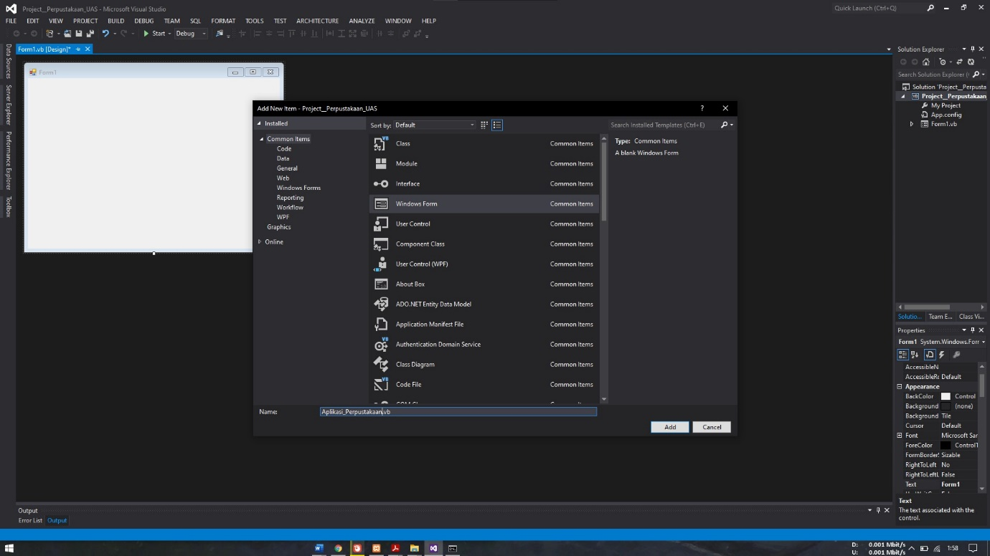

1. Klik Add dan akan menampilkan lembar baru

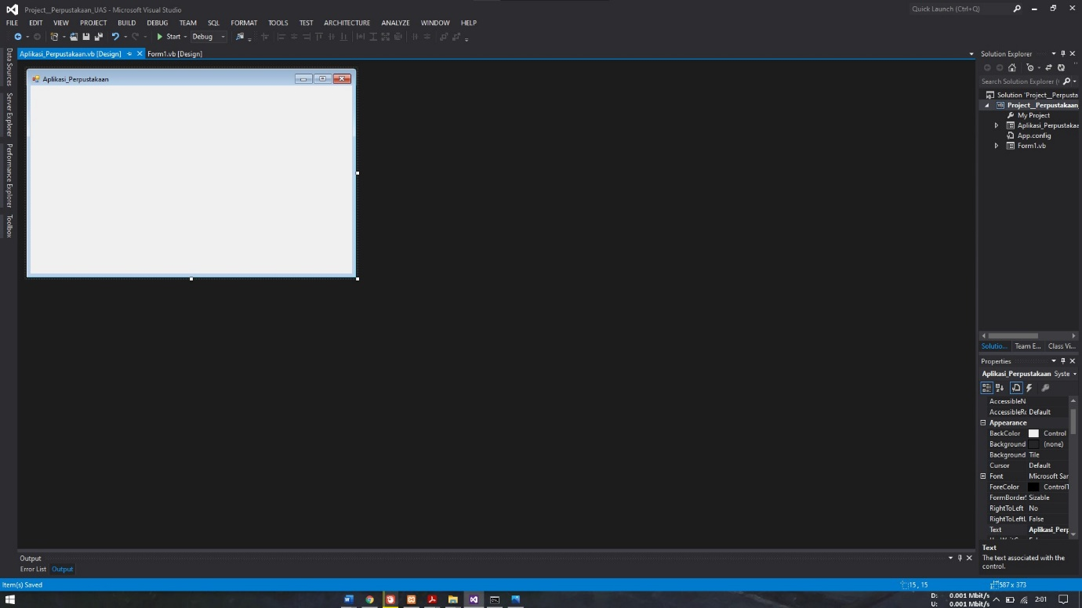

**BAB III**

**PROSES MEMBUAT FORM DAN MENAMBAH LISTING**

1. **Form Utama / Aplikasi_Perpustakaan**
2. Form Aplikasi Perpustakaan

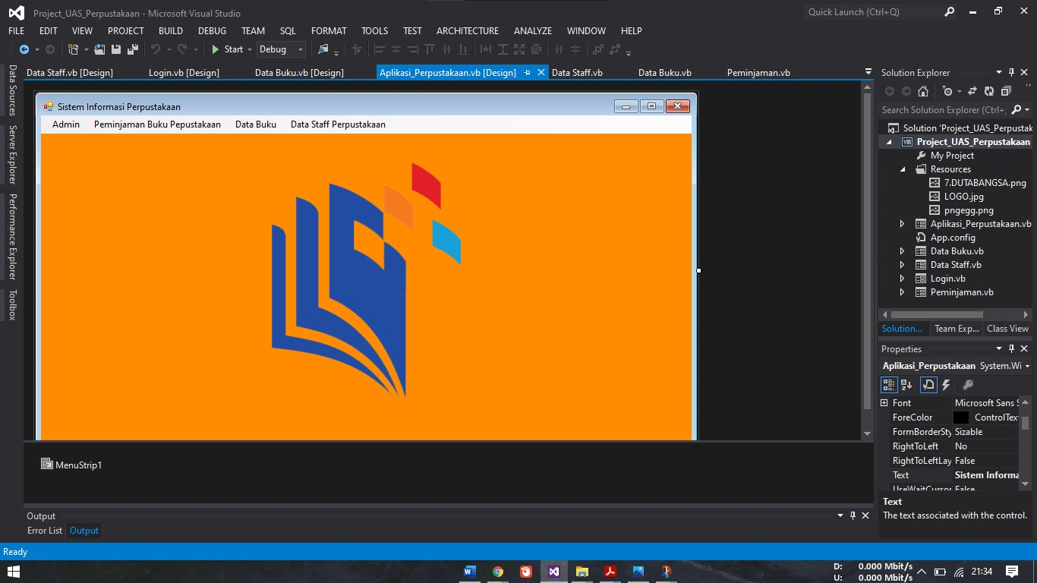

1. Saat Di proses

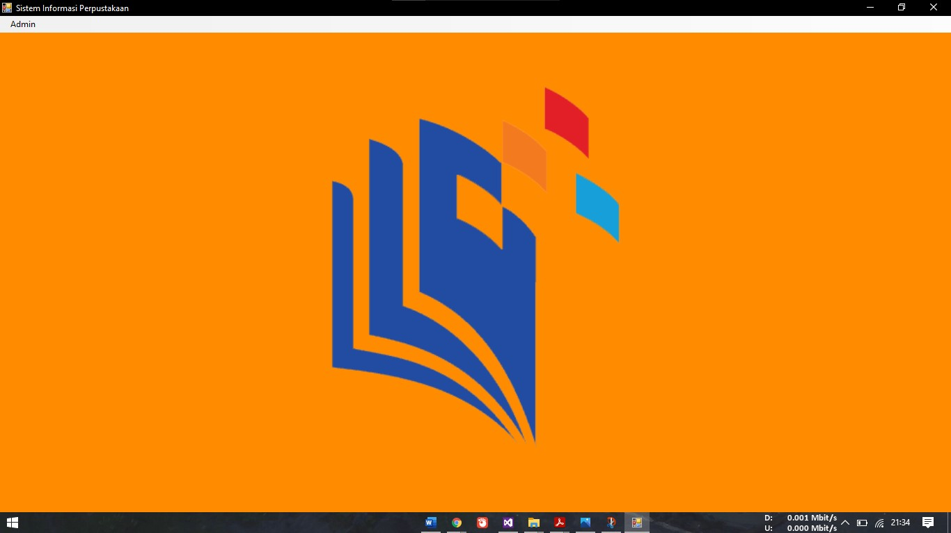

1. Komponen Yang digunakan Form Utama

|  |  |  |
| --- | --- | --- |
| Nama Control | Properties | Value |
| Form | Text | Sistem Informasi Perpustakaan |
| Menu Strip 1 | Text | Admin (Login, Keluar), Peminjaman Buku Perpustakann, Data Buku, Data Staff Perpustakaan |

1. Listing Program

Public Class Aplikasi_Perpustakaan

Sub terkunci()

LoginToolStripMenuItem.Visible = True

DataBukuToolStripMenuItem1.Visible = False

DataStaffPerpustakaanToolStripMenuItem.Visible = False

peminjamanbukuperpustakaan.Visible = False

End Sub

**FORM LOAD**

Private Sub Aplikasi_Perpustakaan_Load(sender As Object, e As EventArgs) Handles MyBase.Load

Call terkunci()

**DATA STAFF PERPUSTAKAAN**

Private Sub DataAnggotaToolStripMenuItem_Click(sender As Object, e As EventArgs) Handles DataStaffPerpustakaanToolStripMenuItem.Click

Data_Staff.Show()

**DATA BUKU**

Private Sub DataBukuToolStripMenuItem1_Click(sender As Object, e As EventArgs) Handles DataBukuToolStripMenuItem1.Click

Data_Buku.Show()

**PEMINJAMAN BUKU PERPUSTAKAAN**

Private Sub MenuToolStripMenuItem_Click(sender As Object, e As EventArgs) Handles peminjamanbukuperpustakaan.Click

Peminjaman.Show()

**LOGIN**

Private Sub LoginToolStripMenuItem_Click(sender As Object, e As EventArgs) Handles LoginToolStripMenuItem.Click

Login.Show()

End sub

**KELUAR**

Me.Close()

1. **Form Login**
2. Form Login

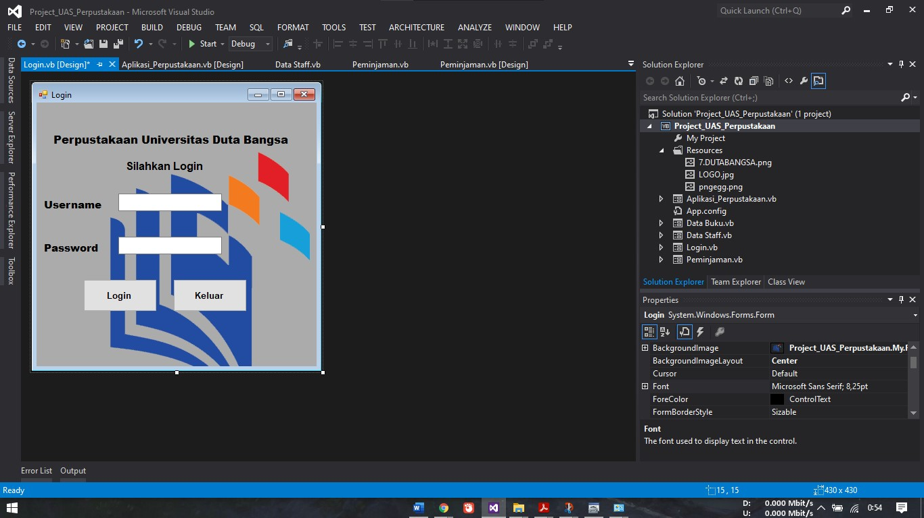

1. Form Login, Sebelum Login Maka Menu Yang Lain Akan Di Sembunyikan

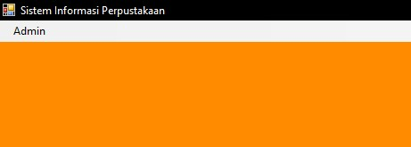

1. Form Login Klik Login

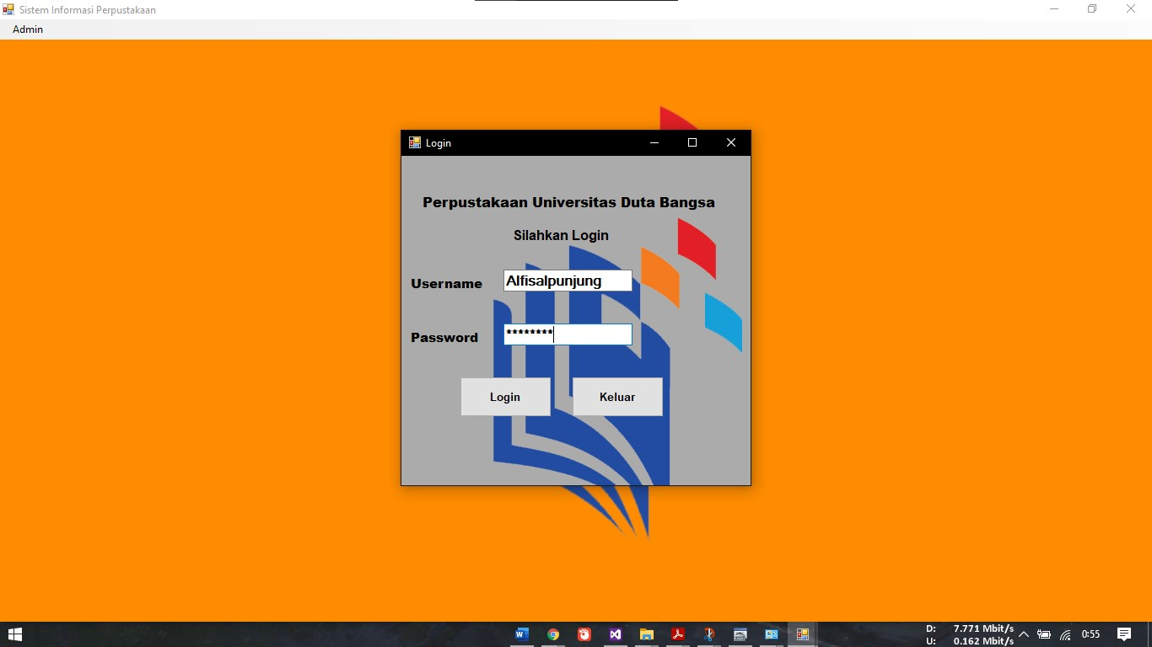

1. Setelah Login Akan Menampilkan Menu Yang Lain

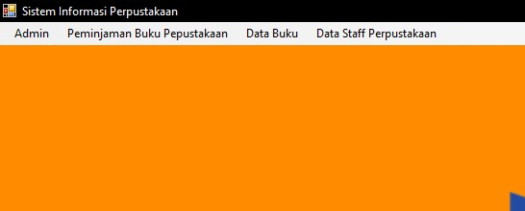

1. Komponen Yang Digunakan Di Form Login

|  |  |  |
| --- | --- | --- |
| Nama Control | Properties | Value |
| Form | Text | Login |
| Label 1 -4 | Text | Perpustakann Universitas Dutabangsa, Silahkan Login, Username, Password |
| TextBox 1-2 | Text | TextBox1, TextBox2 |
| Button 1-2 | Text | Login, Keluar |

1. Listing Form Login

**GENERAL**

Imports System.Data.Odbc

Public Class Login

Dim con As OdbcConnection

Dim dr As OdbcDataReader

Dim da As OdbcDataAdapter

Dim ds As DataSet

Dim dt As DataTable

Dim cmd As OdbcCommand

Dim MyDb As String

**KONEKSI**

Sub koneksi()

MyDb ="Driver={MySQL ODBC 8.0 ANSI Driver};database=db_perpustakaan;server=localhost;uid=root "

con = New OdbcConnection(MyDb)

If con.State = ConnectionState.Closed Then con.Open()

End Sub

**TERBUKA**

Sub terbuka()

Aplikasi_Perpustakaan.LoginToolStripMenuItem.Visible = False

Aplikasi_Perpustakaan.DataBukuToolStripMenuItem1.Visible = True

Aplikasi_Perpustakaan.DataStaffPerpustakaanToolStripMenuItem.Visible=True

Aplikasi_Perpustakaan.peminjamanbukuperpustakaan.Visible = True

End Sub

**FORM LOAD**

Private Sub Login_Load(sender As Object, e As EventArgs) Handles MyBase.Load

TextBox2.PasswordChar = "*"

End Sub

**BUTTON KELUAR**

Private Sub Button2_Click(sender As Object, e As EventArgs) Handles Button2.Click

Me.Close()

End Sub

**BUTTON LOGIN**

Private Sub Button1_Click(sender As Object, e As EventArgs) Handles Button1.Click

If TextBox1.Text = "" Or TextBox2.Text = "" Then

MsgBox("Silahkan Masukan Username Dan Password !!!")

Else

koneksi()

cmd = New OdbcCommand("select *from tb_admin where kodeadmin='" & TextBox1.Text & "' and passadmin='" & TextBox2.Text & "'", con)

dr = cmd.ExecuteReader

dr.Read()

If dr.HasRows Then

Me.Close()

Call terbuka()

Else

MsgBox("Yang Anda Masukan Salah")

End If

End If

End Sub

End Class

1. **Form Staff**
2. Form Data Staff Perpustakaan

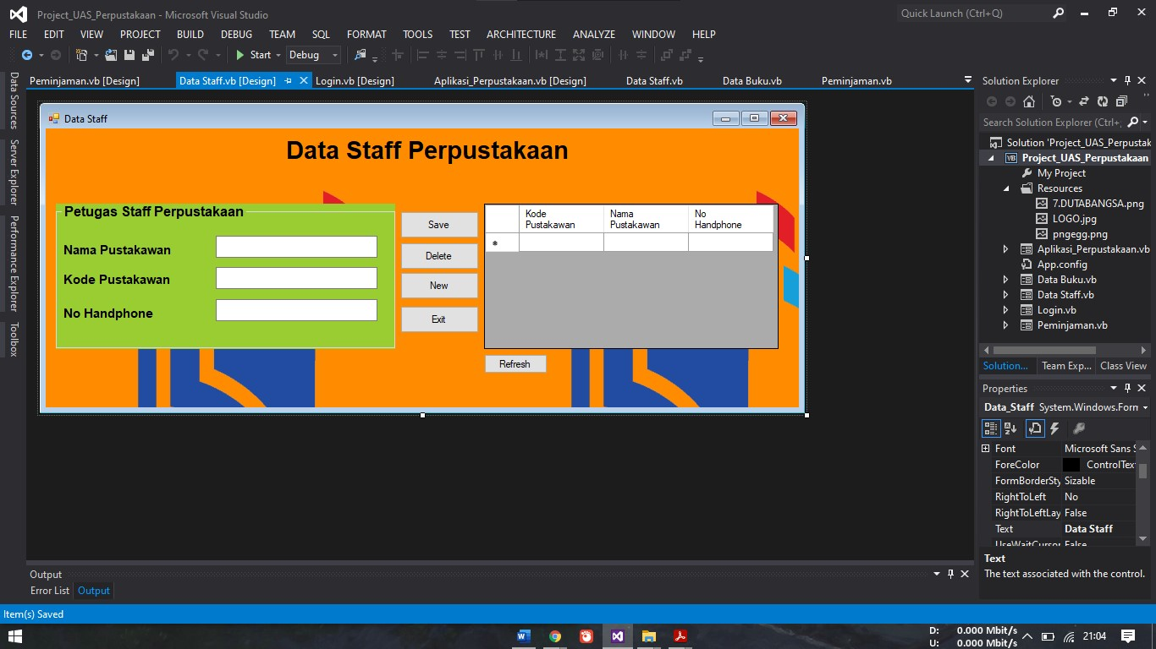

1. Inputan Dari Form Data Staff Perpustakaan, dan Klik Save

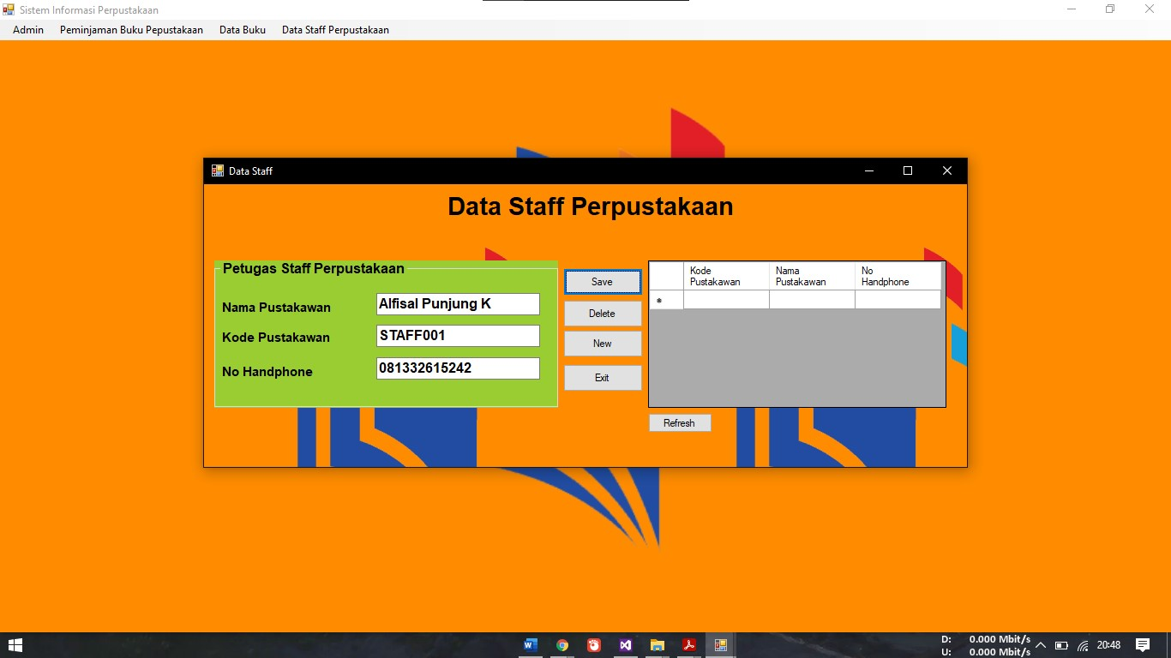

1. Dan Muncul Notifikasi “Menyimpan data berhasil”

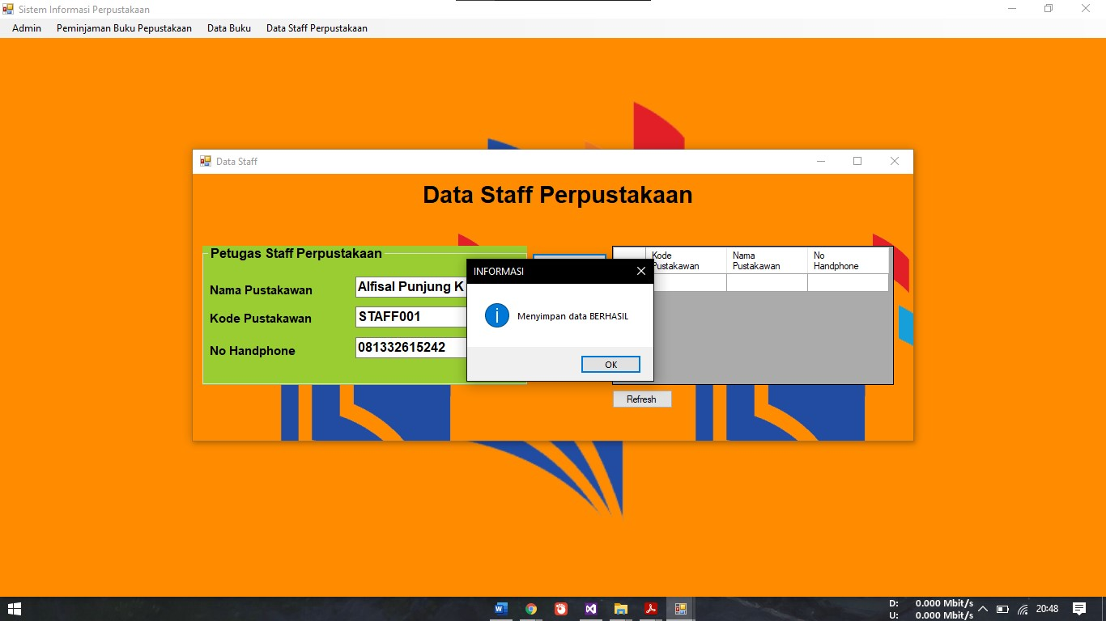

1. Klik Refresh Untuk Memperbarui

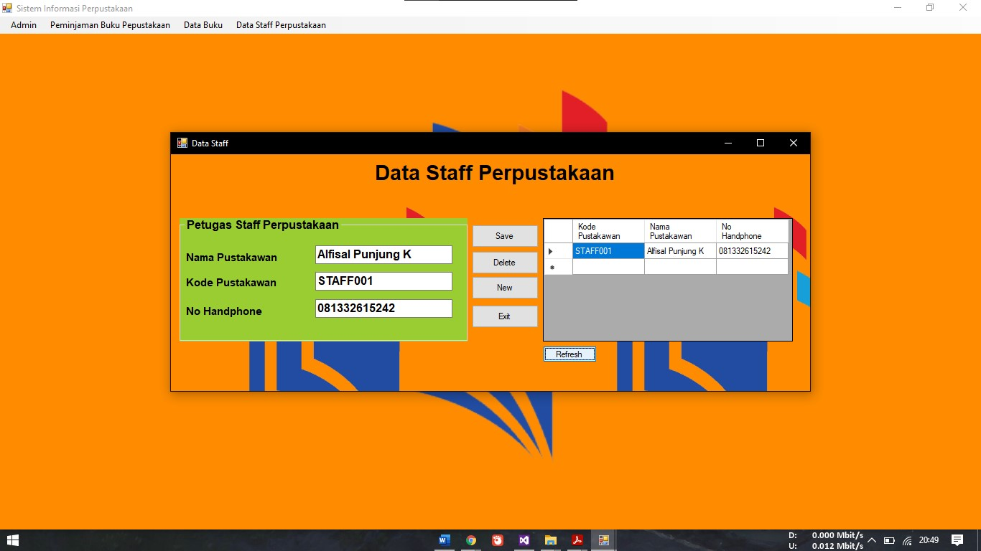

1. Komponen Yang Digunakan Dalam Form Data Staff Perpustakaan

|  |  |  |
| --- | --- | --- |
| Nama Control | Properties | Value |
| Form | Text | Data Staff |
| Label 1 | Text | Data Staff Perpustakaan |
| Label 2-4 | Text | Nama Pustakaan, Kode Pustakawan, No Handphone |
| TextBox 1-3 | Text | Namapus, kodepus, nohan |
| Group Box | Text | Petugas Staff Perpustakaan |
| Data Grid View 1 |  |  |
| Button 1-5 | Text | NEW, SAVE, DELETE, CLOSE, REFRESH |
| DataGridView 1 |  |  |

1. Listing Form Data Staff

**GENERAL**

Imports System.Data.Odbc

Public Class Data_Staff

Dim con As OdbcConnection

Dim dr As OdbcDataReader

Dim da As OdbcDataAdapter

Dim ds As DataSet

Dim dt As DataTable

Dim cmd As OdbcCommand

**KONEKSI**

Sub koneksi()

con = New OdbcConnection

con.ConnectionString = "dsn=db_perpustakaan_uas"

con.Open()

End Sub

**SIMPAN**

Sub simpan()

koneksi()

Dim sql As String = "insert into tbstaff values('" & kodepus.Text & "','" & namapus.Text & "','" & nohan.Text & "')"

cmd = New OdbcCommand(sql, con)

cmd.ExecuteNonQuery()

Try

MsgBox("Menyimpan data BERHASIL", vbInformation, "INFORMASI")

Catch ex As Exception

MsgBox("Menyimpan data GAGAL", vbInformation, "PERINGATAN")

End Try

End Sub

**TAMPIL**

Sub tampil()

DataGridView1.Rows.Clear()

Try

koneksi()

da = New OdbcDataAdapter("select * from tbstaff order by kode_pustakawan asc", con)

dt = New DataTable

da.Fill(dt)

For Each row In dt.Rows

DataGridView1.Rows.Add(row(0), row(1), row(2))

Next

dt.Rows.Clear()

Catch ex As Exception

MsgBox("Menampilkan data GAGAL")

End Try

End Sub

**BUTTON SAVE**

Private Sub Button1_Click(sender As Object, e As EventArgs) Handles Button1.Click

simpan()

End Sub

**BUTTON DELETE**

Private Sub Button2_Click(sender As Object, e As EventArgs) Handles Button2.Click

Dim a As String = DataGridView1.Item(0, DataGridView1.CurrentRow.Index).Value

If a = "" Then

MsgBox("Data Mahasiswa yang dihapus belum DIPILIH")

Else

If (MessageBox.Show("Anda yakin menghapus data dengan nim=" & a & "...?", "Delete", MessageBoxButtons.OKCancel, MessageBoxIcon.Warning) = Windows.Forms.DialogResult.OK) Then

koneksi()

cmd = New OdbcCommand("delete from tbstaff where kode_pustakawan='" & a & "'", con)

cmd.ExecuteNonQuery()

MsgBox("Menghapus data BERHASIL", vbInformation, "INFORMASI")

con.Close()

tampil()

End If

End If

End Sub

**BUTTON NEW**

Private Sub Button3_Click(sender As Object, e As EventArgs) Handles Button3.Click

namapus.Text = ""

kodepus.Text = ""

nohan.Text = ""

namapus.Focus()

End Sub

**BUTTON EXIT**

Private Sub Button4_Click(sender As Object, e As EventArgs) Handles Button4.Click

Me.Close()

**BUTTON REFRESH**

Private Sub Button5_Click(sender As Object, e As EventArgs) Handles Button5.Click

Tampil()

1. **Form Data Buku Perpusatakann**
2. Form Data Buku Perpustakaan

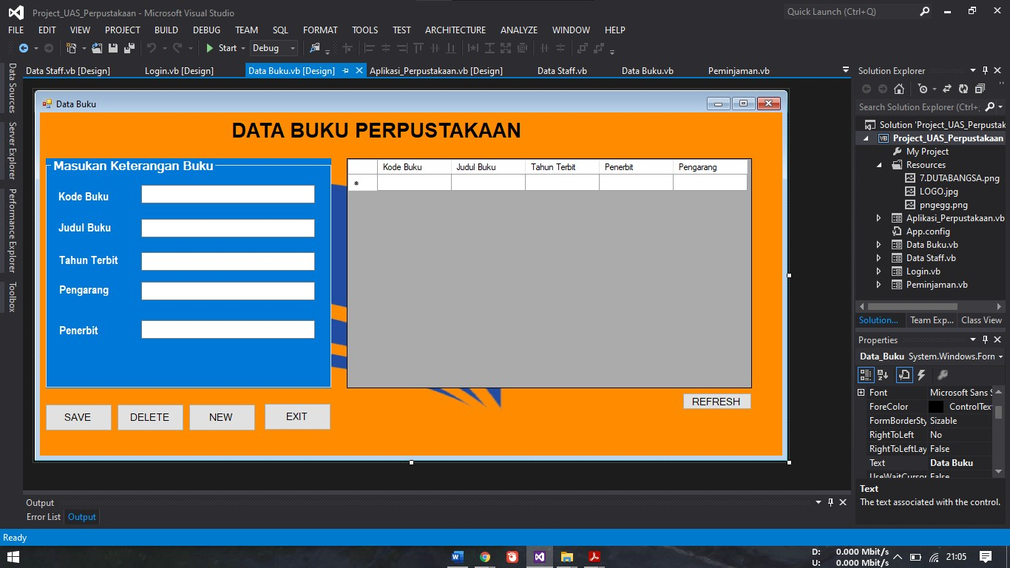

1. Inputkan Data Buku

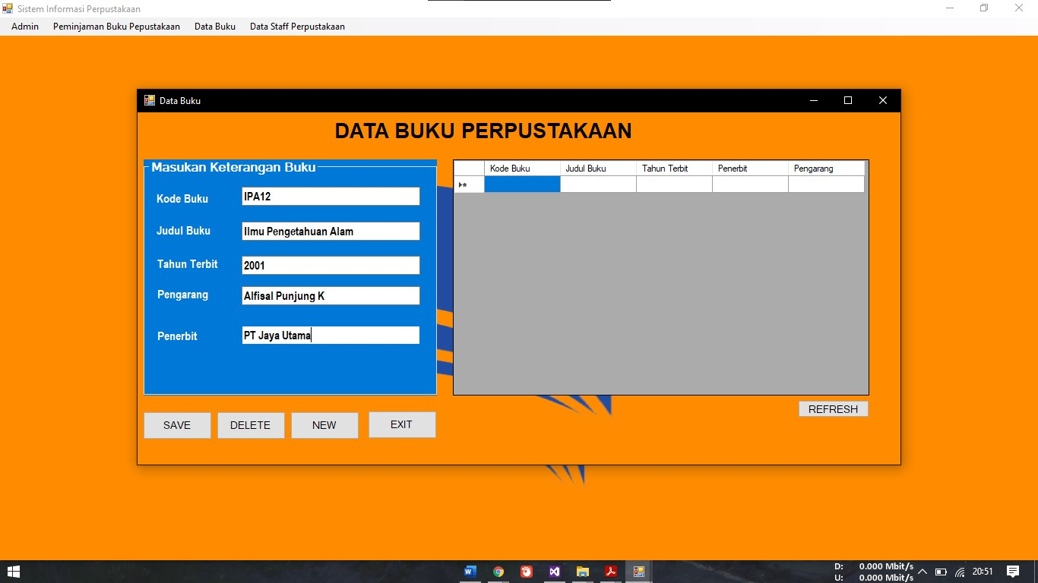

1. Klik Save dan ada notifikasi

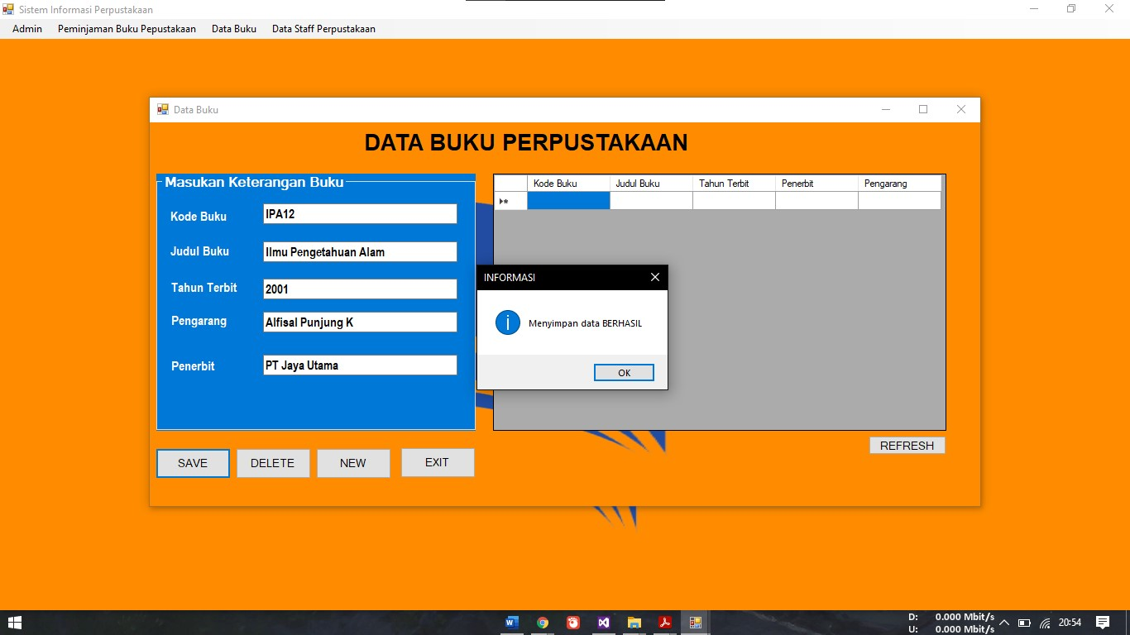

1. Klik Refressh

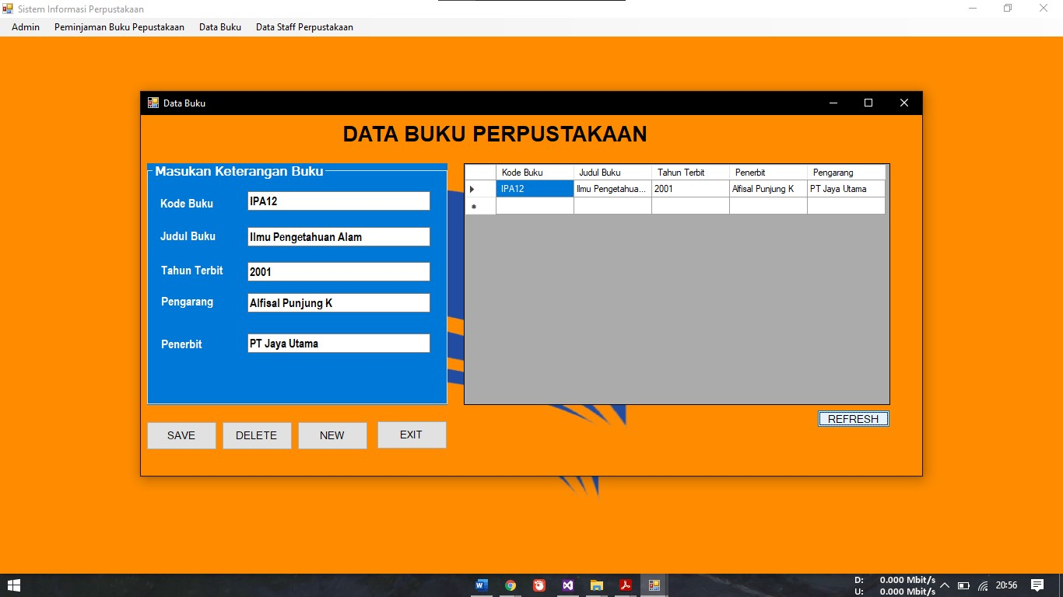

1. Komponen Yang Digunakan

|  |  |  |
| --- | --- | --- |
| Nama Control | Properties | Value |
| Form | Text | DATA BUKU PERPUSTAKAAN |
| Label 1 | Text | Data Staff Perpustakaan |
| Label 2-5 | Text | Kode Buku, Judul Buku, Tahun Terbit, Pengarang, Penerbit |
| TextBox 1-5 | Text | Kodebuk, judulbuk, tahunter, pengarang, penerbit |
| Group Box | Text | Masukan Keterangan Buku |
| Data Grid View 1 |  |  |
| Button 1-5 | Text | NEW, SAVE, DELETE, CLOSE, REFRESH |

1. Listing Form Data Buku

**GENERAL**

Imports System.Data.Odbc

Public Class Data_Buku

Dim con As OdbcConnection

Dim dr As OdbcDataReader

Dim da As OdbcDataAdapter

Dim ds As DataSet

Dim dt As DataTable

Dim cmd As OdbcCommand

Sub koneksi()

con = New OdbcConnection

con.ConnectionString = "dsn=db_perpustakaan_uas"

con.Open()

End Sub

**KONEKSI**

Sub koneksi()

con = New OdbcConnection

con.ConnectionString = "dsn=db_perpustakaan_uas"

con.Open()

End Sub

**SIMPAN**

Sub simpan()

koneksi()

Dim sql As String = "insert into tbbuku values (' " & kodebuk.Text & "','" & judulbuk.Text & "', '" & tahunter.Text & "', '" & pengarang.Text & "', '" & penerbit.Text & "')"

cmd = New OdbcCommand(sql, con)

cmd.ExecuteNonQuery()

Try

MsgBox("Menyimpan data BERHASIL", vbInformation, "INFORMASI")

Catch ex As Exception

MsgBox("Menyimpan data GAGAL", vbInformation, "PERINGATAN")

End Try

End Sub

**TAMPIL**

Sub tampil()

DataGridView1.Rows.Clear()

Try

koneksi()

da = New OdbcDataAdapter("select *from tbbuku order by kode_buku asc ", con)

dt = New DataTable

da.Fill(dt)

For Each row In dt.Rows

DataGridView1.Rows.Add(row(0), row(1), row(2), row(3), row(4))

Next

dt.Rows.Clear()

Catch ex As Exception

MsgBox("Menampilkan data GAGAL !!!")

End Try

End Sub

**FROM LOAD**

Private Sub Data_Buku_Load(sender As Object, e As EventArgs) Handles MyBase.Load

tampil()

End Sub

**BUTTON SAVE**

Private Sub Button1_Click(sender As Object, e As EventArgs) Handles Button1.Click

simpan()

End Sub

**BUTTON DELETE**

Private Sub Button2_Click(sender As Object, e As EventArgs) Handles Button2.Click

Dim a As String = DataGridView1.Item(0, DataGridView1.CurrentRow.Index).Value

If a = "" Then

MsgBox("Data Mahasiswa yang dihapus belum DIPILIH")

Else

If (MessageBox.Show("Anda yakin menghapus data dengan nim=" & a & "...?", "Delete", MessageBoxButtons.OKCancel, MessageBoxIcon.Warning) = Windows.Forms.DialogResult.OK) Then

koneksi()

cmd = New OdbcCommand("delete from tbbuku where kode_buku='" & a & "'", con)

cmd.ExecuteNonQuery()

MsgBox("Menghapus data BERHASIL", vbInformation, "INFORMASI")

con.Close()

tampil()

End If

End If

End Sub

**BUTTON NEW**

Private Sub Button3_Click(sender As Object, e As EventArgs) Handles Button3.Click

kodebuk.Text = ""

judulbuk.Text = ""

penerbit.Text = ""

tahunter.Text = ""

pengarang.Text = ""

kodebuk.Focus()

End Sub

**BUTTON EXIT**

Private Sub Button4_Click(sender As Object, e As EventArgs) Handles Button4.Click

Me.Close()

Me.Close()

End Sub

1. **Form Peminjaman**
2. Form Peminjaman

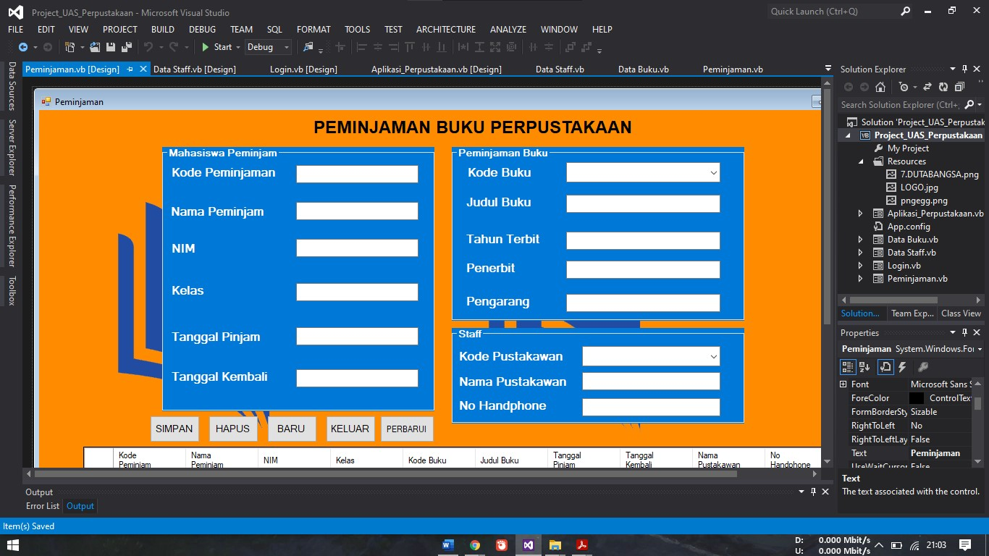

1. Masukan Inputan Peminjaman Buku

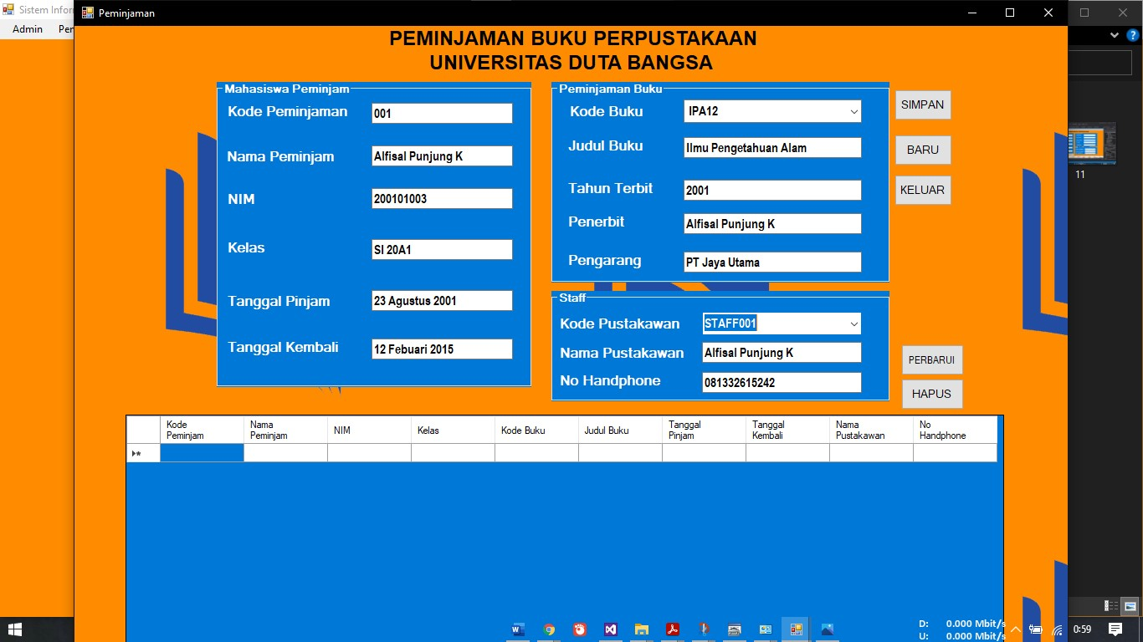

1. Klik Save

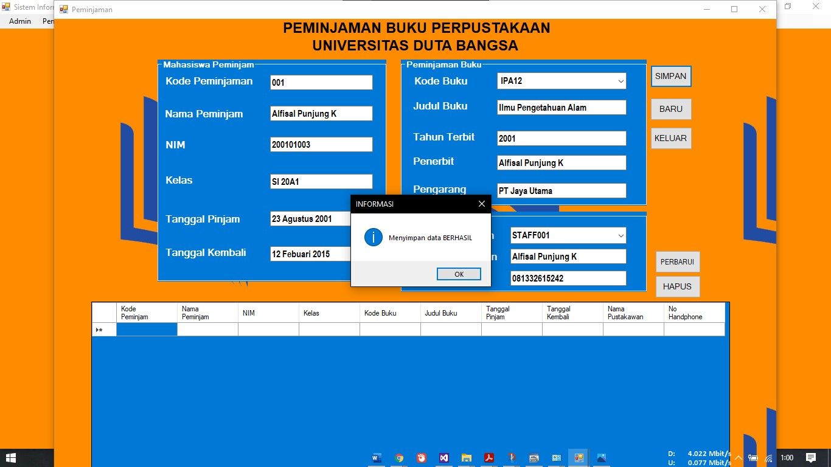

1. Lalu Klik Refresh

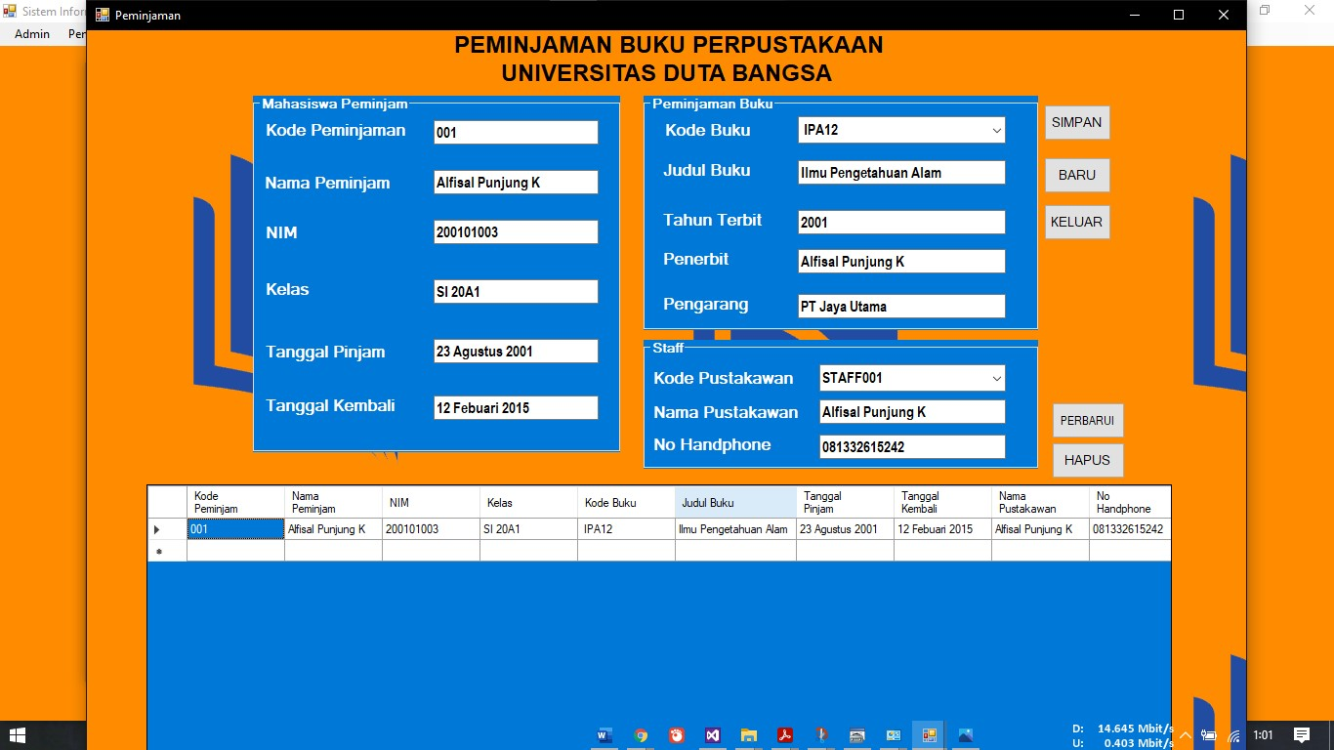

1. Komponen Yang Digunakan

|  |  |  |
| --- | --- | --- |
| Nama Control | Properties | Value |
| Form | Text | Peminjaman |
| Label 1 | Text | PEMINJAMAN BUKU PERPUSTAKAAN UNIVERSITAS DUTA BANGSA |
| Label 2-15 | Text | Kode Peminjam, Nama Peminjam, NIM, Kelas, Tanggal Pinjam, Tanggal Kembali, Kode Buku, Judul Buku, Tahun Terbit, Penerbit, Pengarang |
| TextBox 1-12 | Text  Name | Kodepem, namapem, nim, kelas, tanggalpin, tanggalkem, comkodbuk, judulbuk, tahunter, penerbit, pengarang, kodepus, namapus, nohan |
| ComboBox 1-2 | Text  Name | Comkodebuk, kodepus |
| Group Box 1-3 | Text | Mahasiswa Peminjam, Peminjaman Buku, Staff |
| Data Grid View 1 |  |  |
| Button 1-5 | Text | NEW, SAVE, DELETE, CLOSE, REFRESH |

1. Listing Program

**GENERAL**

Imports System.Data.Odbc

Public Class Peminjaman

Dim con As OdbcConnection

Dim dr As OdbcDataReader

Dim da As OdbcDataAdapter

Dim ds As DataSet

Dim dt As DataTable

Dim cmd As OdbcCommand

**KONEKSI**

Sub koneksi()

con = New OdbcConnection

con.ConnectionString = "dsn=db_perpustakaan_uas"

con.Open()

End Sub

**SIMPAN**

Sub simpan()

koneksi()

Dim sql As String = "insert into tbpeminjam values('" & kodepem.Text & "','" & namapem.Text & "','" & nim.Text & "','" & kelas.Text & "','" & comkodbuk.Text & "','" & judulbuk.Text & "','" & tanggalpinjam.Text & "','" & tanggalkem.Text & "','" & namapus.Text & "','" & nohan.Text & "')"

cmd = New OdbcCommand(sql, con)

cmd.ExecuteNonQuery()

Try

MsgBox("Menyimpan data BERHASIL", vbInformation, "INFORMASI")

Catch ex As Exception

MsgBox("Menyimpan data GAGAL", vbInformation, "PERINGATAN")

End Try

End Sub

**TAMPIL**

Sub tampil()

DataGridView1.Rows.Clear()

Try

koneksi()

da = New OdbcDataAdapter("select *from tbpeminjam order by kode_peminjam asc", con)

dt = New DataTable

da.Fill(dt)

For Each row In dt.Rows

DataGridView1.Rows.Add(row(0), row(1), row(2), row(3), row(4), row(5), row(6), row(7), row(8), row(9))

Next

dt.Rows.Clear()

Catch ex As Exception

MsgBox("Menampilkan data GAGAL")

End Try

End Sub

**TAMPIL BUKU**

Sub tampilbuku()

cmd = New OdbcCommand("select kode_buku from tbbuku", con)

dr = cmd.ExecuteReader

comkodbuk.Items.Clear()

Do While dr.Read

comkodbuk.Items.Add(dr.Item("kode_buku"))

Loop

End Sub

**TAMPIL STAFF**

Sub tampil_staff()

cmd = New OdbcCommand("select kode_pustakawan from tbstaff", con)

dr = cmd.ExecuteReader

kodepus.Items.Clear()

Do While dr.Read

kodepus.Items.Add(dr.Item("kode_pustakawan"))

Loop

End Sub

**COMBO BOX PEMINJAMAN BUKU**

Private Sub comkodbuk_SelectedIndexChanged(sender As Object, e As EventArgs) Handles comkodbuk.SelectedIndexChanged

cmd = New OdbcCommand("select * from tbbuku where kode_buku='" & comkodbuk.Text & "'", con)

dr = cmd.ExecuteReader

dr.Read()

If dr.HasRows Then

judulbuk.Text = dr.Item("judul_buku")

tahunter.Text = dr.Item("tahun_terbit")

penerbit.Text = dr.Item("penerbit")

pengarang.Text = dr.Item("pengarang")

Else

MsgBox("Maaf buku yang dicari belum di inputkan ke sistem !!!")

End If

comkodbuk.Focus()

End Sub

**COMBOBOX KODE PUSTAKAWAN**

Private Sub kodepus_SelectedIndexChanged(sender As Object, e As EventArgs) Handles kodepus.SelectedIndexChanged

cmd = New OdbcCommand("select * from tbstaff where kode_pustakawan='" & kodepus.Text & "'", con)

dr = cmd.ExecuteReader

dr.Read()

If dr.HasRows Then

namapus.Text = dr.Item("nama_pustakawan")

nohan.Text = dr.Item("no_handphone")

Else

MsgBox("Maaf Staff Tidak Terdaftar Di Sistem")

End If

kodepus.Focus()

End Sub

**BUTTON SIMPAN**

Private Sub Button1_Click(sender As Object, e As EventArgs) Handles Button1.Click

simpan()

**BUTTON BARU**

Private Sub Button3_Click(sender As Object, e As EventArgs) Handles Button3.Click

kodepem.Text = ""

namapem.Text = ""

nim.Text = ""

tanggalpinjam.Text = ""

kelas.Text = ""

tanggalkem.Text = ""

comkodbuk.Text = "-pilih-"

judulbuk.Text = ""

tahunter.Text = ""

penerbit.Text = ""

pengarang.Text = ""

kodepus.Text = "-PILIH-"

pengarang.Text = ""

pengarang.Text = ""

namapus.Text = ""

nohan.Text = ""

kodepem.Focus()

End Sub

**BUTTON KELUAR**

Private Sub Button4_Click(sender As Object, e As EventArgs) Handles Button4.Click

Me.Close()

End Sub

**BUTTON PERBARUI**

Private Sub Button5_Click(sender As Object, e As EventArgs) Handles Button5.Click

tampil()

End Sub

**BUTTON HAPUS**

Private Sub Button2_Click(sender As Object, e As EventArgs) Handles Button2.Click

Dim a As String = DataGridView1.Item(0, DataGridView1.CurrentRow.Index).Value

If a = "" Then

MsgBox("Data Nilai yang dihapus belum DIPILIH")

Else

If (MessageBox.Show("Anda yakin menghapus data dengan kode_peminjam=" & a & "...?", "Delete", MessageBoxButtons.OKCancel, MessageBoxIcon.Warning) = Windows.Forms.DialogResult.OK) Then

koneksi()

cmd = New OdbcCommand("delete from tbpeminjam where kode_peminjam='" & a & "'", con)

cmd.ExecuteNonQuery()

MsgBox("Menghapus data nilai BERHASIL", vbInformation, "INFORMASI")

con.Close()

tampil()

End If

End If

End Sub

1. LINK GOOGLE DRIVE :